Third Seminar on Algebra and its Applications (TSAA 2014)

Seminar Registration Form

University of Mohaghegh Ardabili

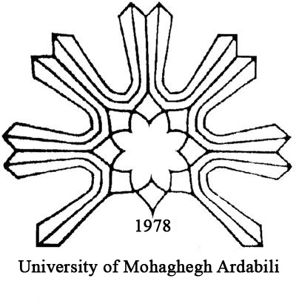
Ardabil, Iran

Send Completed Registration Forms to:
tsaa@uma.ac.ir

CC Completed Registration Forms to:
ard.algsem@gmail.com

Deadline for registration:

For participants from Iran: 15 Mordad 1393

For international Participants: June 25, 2014

1. Participant Information
Title: Prof. Dr. Mr. Ms. Mrs.
First Name: |  | Last Name:
Title/Position
Organisation
Address:
Address: | Country | City:
Phone No’s | Work: |  | Mobile:
Email address

2. Conference Fee
Registration Fees
Categories | Registration fee |  |  | Registration Type
Categories | Iranians | Foreigners |  | Registration Type
Student for the first paper | 1200000IRR |  | 150$
Regular for the first paper | 2400000IRR |  | 250$
Student for the second or more papers (per paper) | 500000IRR |  | 50$
Regular for the second or more papers (per paper) | 700000IRR |  | 75$
Accompanying person registration | 1300000IRR |  | 100$

The registration fee covers:
- Admission to the Scientific sessions & Exhibition Area
- Seminar Material (program, proceedings, congress, bag, etc.)
- Coffee breaks
- Lunch, Dinner and Breakfast
- Accommodation
- Sar’eyn Tour

Payment Method:
For Participants from Iran: Refer to the website of the seminar: www.uma.ac.ir/links/tsaa

For International Participants: At the registration desk.

